Negotiating return to work in the age of demographic change through industrial relations (VS/2019/0075)
Slovakia
Indicators for work incapacity, chronic disease and collective bargaining*
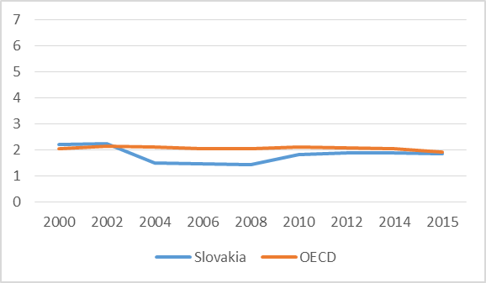 | 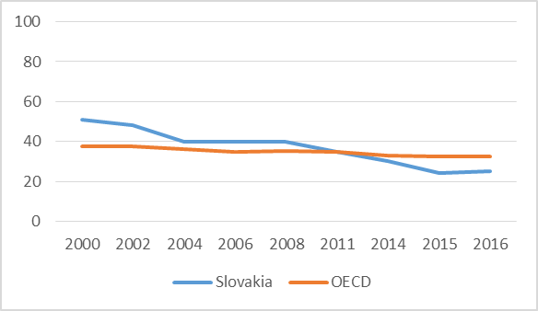 |  |  | 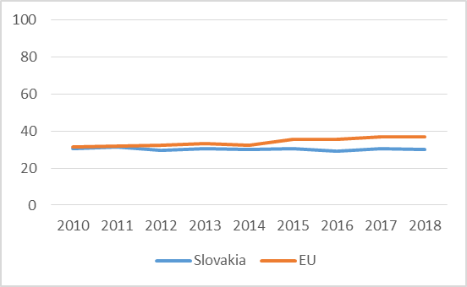
Public spending on incapacity (% of GDP) | Collective bargaining coverage (%) |  |  | Chronic morbidity (% persons with chronic illness or health problems)
Policy framework and key issues for return to work
- Limited dedicated policy framework for return to work after chronic disease, policies essentially target only persons with a formally recognized status of disability  - Support for two basic categories: recipients of invalidity benefit and people with a severe health disability status  - Some general policy measures and legislation supportive in the return-to-work process  - Key legal documents: Labour Code (Act No. 311/2001), Sickness benefit (Act No. 462/2003), Social Insurance (Act No. 461/2003) |  | - Vocational rehabilitation support  - Income compensation - temporary work incapacity  - Prohibition of notice during temporary work incapacity  - Sickness and invalidity benefit system  - Stakeholders’ support to workers returning to work remains isolated (patient organizations, medical professionals, employers, NGOs, etc.)  - Lack of stakeholder cooperation to facilitate return-to-work after chronic disease
Policy framework |  | Key policy issues
Involvement of social partners in return to work policies
- System of tripartite and bipartite social dialogue, but return-to-work after chronic illness not a priority area  - Peak-level employers’ associations and trade unions can file proposals to RTW policy amendment via tripartism and membership in various bi- and tripartite committees  - Low actual capacity of social partners to improve the RTW policy and implementation  - Lacking cooperation between stakeholders (e.g. social partners, government, NGOs), improvement desired |  | - Collective bargaining at sectoral/company level – opportunity to stipulate return to work provisions  - Employers’ involvement perceived as sufficient, but demand for more trade union action  - Workers expect trade unions to address health-related issues and facilitate return to work remedies vis-à-vis employers  - Unclear responsibility and control of the return to work procedure is a barrier for more systemic approach to sustainable return to work policies
National level |  | Workplace level
Policy recommendations
Recommendations for policymakers  - Policy to clearly distinguish between people with and without a formal disability status  - Policy alignment between various governance levels (national, sector, workplace)  - Systematic data collection on persons with chronic diseases returning to work |  | Recommendations for social partners  - Systematic approach to return to work at workplaces  - More active role for trade unions in return to work  - Closer cooperation of involved stakeholders  - Learning from good practices in other countries
Further information
Project details: https://www.celsi.sk/en/projects/detail/64/, contact: Central European Labour Studies Institute (adam.sumichrast@celsi.sk)
*Sources: Data on public spending on incapacity and collective bargaining coverage is taken from the OECD. Chronic morbidity is taken from the Eurostat.

