Negotiating return to work in the age of demographic change through industrial relations (VS/2019/0075)
Estonia
General indicators for work incapacity, industrial relations and chronic disease*
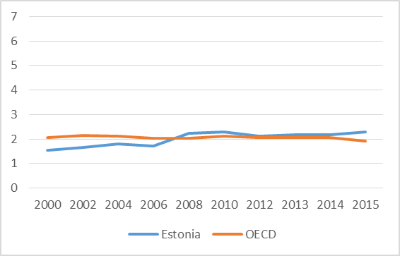 | 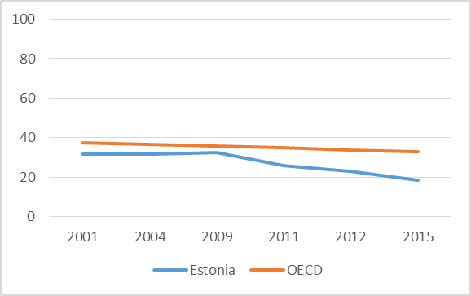 |  |  | 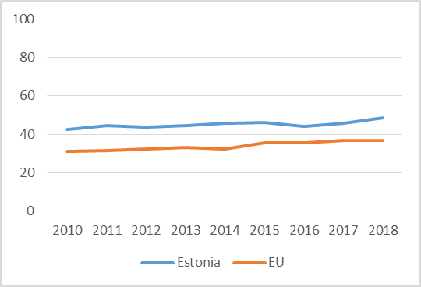
Public spending on incapacity (% of GDP) | Collective bargaining coverage (%) |  |  | Chronic morbidity (people having long-standing illness or health problems)
Policy framework and key issues for return to work
Estonia has neoliberal, company-based industrial relations system, and has been seen as offering limited institutional support and ad hoc policy initiatives in return to work, with sufficient regulation but low uptake. Key provisions:  - Employment Contracts Act  - Health Insurance Act  - Work Ability Allowance Act  - Occupational Health and Safety Act |  | - Public policy mix in Estonia supports labour market inclusion of people with limited work capability resulting from occupational or non-occupational injury, illness or disability  - Employment of people with reduced work capability is addressed by integrated interventions in several policy areas: ALMPs, social welfare, medical treatment, rehabilitation  - The system is difficult to navigate, perceived as scattered, and enforcement of worker rights is missing
Policy framework |  | Key policy issues
Involvement of social partners in return to work policies
- Trade unions and employers’ organisations are mobilised by the Ministry of Social Affairs since their own interest and motivation of engagement is relatively low as they do not feel notable dissatisfaction with the present situation, have stronger interests elsewhere and feel they have made the contribution already |  | - Employment of people with reduced work capability is a matter to be resolved between the employee, the management and the Unemployment Insurance Fund that offers a range of support measures to both employees and employers  - Labor inspectorate oversees the situation and assures that guidelines are followed
National level |  | Company-level
Policy recommendations
Recommendations for policymakers  - The Ministry of Social Affairs is recommended to  - keep monitoring and analysing employment of people with reduced work capability, and developing relevant interventions.  - communicate rights and duties of employers and employees better to respective groups.  - The Unemployment Insurance Fund is recommended to communicate services it provides to employees with reduced work capability and to employers who hire employees with reduced work capability. |  | Recommendations for social partners  - Trade unions are recommended to take a more active role in negotiations between employees and employers to support employees in return to work  - Patient organisations could become more involved in promoting workers’ rights at return to work, possibly becoming a one-stop-shop for information in regard to possible working life with a given illness  - Employer associations should increase awareness of the issue among employers and share good practices of employer support in the case of occurrence of chronic illness and/or return to work for inspiration and guidance.
Further information
References
*Sources: Data on public spending on incapacity and collective bargaining coverage are taken from OECD. Chronic morbidity is taken from Eurostat.

Data on public spending on incapacity and collective bargaining coverage is taken from the OECD. Chronic morbidity is taken from the Eurostat
The concept is operationalized by asking if the respondent suffers from any longstanding (of a duration of at least six months) illness or health problem.

