Negotiating return to work in the age of demographic change through industrial relations (VS/2019/0075)
Belgium
General indicators for work incapacity, industrial relations and chronic disease*
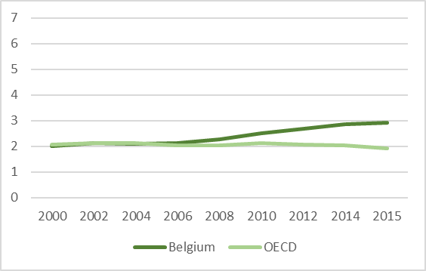 | 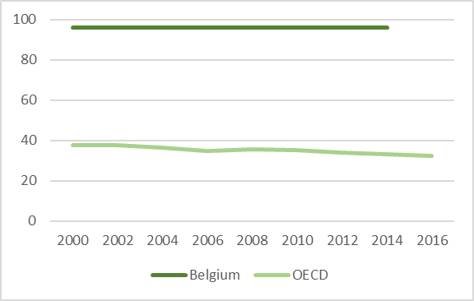 |  |  |  | 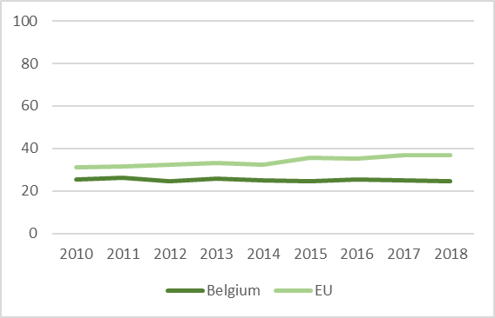
Public spending on incapacity (% of GDP) | Collective bargaining coverage (%) |  |  |  | Chronic morbidity (people having longstanding illness or health problems)
Policy framework and key issues for return to work
- Act of 4 August 1996 on Wellbeing at Work (Chapter 4)  - Law of 3 July 1978 on Employment Contracts  - Compulsory Healthcare and Indemnity Insurance Legislation of 14 July 1994  - Anti-discrimination Legislation |  | - Lack of coordination between health professionals  - High incidence of contract termination due to medical reasons and lack of support for employees declared permanently unfit to return to the same company  - Insufficient support for SMEs to implement reasonable accommodations
Policy framework |  | Key policy issues
Involvement of social partners in return to work policies
- Strong culture of social dialogue, high unionisation rate and collective bargaining coverage, media presence  - Involvement in legislation via the National Labour Council and the High Council for Prevention and Protection at Work |  | - Responsibility of health and safety committee to create an internal company reintegration policy  - Obligation for the employer to draft individual reintegration plans  - Possibility for union delegates to help the employee during negotiations with the employer and colleagues
National level |  | Company level
Policy recommendations
Recommendations for policymakers  - Address the initial design flaws of the legislation on reintegration procedures  - Collect reliable and systematic data on return to work  - Foster tailored vocational rehabilitation programmes  - Audit companies with high incidence of incapacity |  |  | Recommendations for social partners  - Include return to work in a cross-sectoral collective agreement on wellbeing at work  - Draft joint cross-sectoral or sectoral guidelines on the design of a company-level reintegration policy  - Continue raising awareness by training affiliates
Further information
References
Lopez Uroz, N., L. Westhoff and M. Akgüç (2020), Working paper on national-level and company-level industrial relations actors’ involvement in facilitating return to work policies and identifying best practices – Country Report for Belgium, Brussels.
Mutualités Libres (2019), Reprendre le travail pendant une période d’incapacité, Brussels.

*Sources: Data on public spending on incapacity and collective bargaining coverage is taken from the OECD. Chronic morbidity is taken from Eurostat.

The concept is operationalised by a question asking if the respondent suffers from any longstanding (of a duration of at least six months) illness or health problem.

