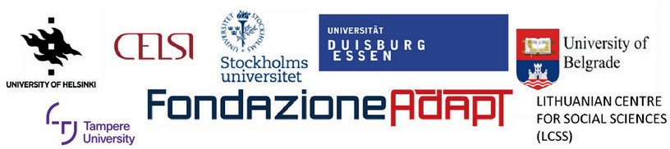

DEFEN-CE:

DEFEN-CE:
Social Dialogue in Defence of Vulnerable Groups in Post-COVID-19 Labour Markets

Comparative report
Deliverable D4.2

Marta Kahancová

Central European Labour Studies Institute

With contributions from the DEFEN-CE research team

European Union
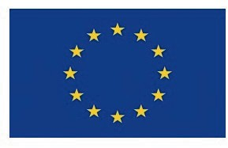
No. VS/2021/0196

Table of Contents
Introduction 3
1. Project objectives and aims 4
2. Conceptualization of vulnerable groups 5
3. Methodology 7
4. Vulnerable groups in the (post)COVID-19 labour markets 10
5. The DEFEN-CE database of policy measures 11
6. Social dialogue in protecting vulnerable groups: EU-level strategies and responses 14
7. Social dialogue in protecting vulnerable groups: country-level responses 15
7.1 Baltic neoliberalism: Latvia and Lithuania 15
7.2 Continental Western Europe: Germany and the Netherlands 17
7.3 Embedded neoliberalism: Czechia and Slovakia 19
7.4 Nordic corporatism: Finland and Sweden 21
7.5 Southern social dialogue model: Italy and Spain 23
7.6 Candidate country - Serbia 25
7.7 Candidate country - Turkey 26
8. Conclusions 28
References 30

Introduction

The COVID-19 pandemic has generated unprecedented health and far-reaching life consequences, triggering a global social and economic crisis through its protective measures aimed at safeguarding lives. This crisis compels social scientists and researchers to scrutinize the deficiencies in social and economic readiness and responses to the pandemic.
The DEFEN-CE project, supported by the European Commission, delves into institutional strategies and power dynamics in social protection, policy formulation, and implementation. It sought to safeguard labour markets and workers by examining the governance of vulnerable groups in the (post) COVID-19 labor markets. Moreover, it aimed to generate research-based knowledge at EU and national levels, including candidate countries, on the role of social partners in creating and implementing protective policies vis-à-vis vulnerable groups.
This report spotlights all key project findings both at the EU-level and the national level in 12 countries, embedding them to a conceptual understanding of vulnerability in general and labour-market related vulnerability in particular. The research was guided by three research questions:
- What public policy and social dialogue measures targeting the selected vulnerable groups were implemented to employment and social protection during the COVID-19 pandemic 2020-2022?
- To what extent and how did social dialogue play a role in the implementation of social and employment rights of selected vulnerable groups in the COVID-19 pandemic between 2020 and 2022?
- What lessons and opportunities does the COVID-19 pandemic yield for strengthening social dialogue across EU member states and the candidate countries?
The report is structured as follows. The first section highlights the project aims. The second section summarizes the conceptualization of vulnerable groups, which have been elaborated in great depth in a separate working paper (Holubová and Kahancová 2024). The third section reviews the multiple methodologies used in the DEFEN-CE project to collect and analyze data. The fourth section presents a summary of findings on EU-level strategies of key stakeholders to protect vulnerable groups and the role of social dialogue in these strategies. The fifth section summarizes the country findings across 12 countries, following the adopted comparative structure of comparing country pairs with most similar industrial relations systems (5 country pairs, in total 10 EU Member States: Czechia and Slovakia, Latvia and Lithuania, Germany and the Netherlands, Finland and Sweden, France and Italy) plus two individual country analyses of candidate countries (Serbia and Turkey). The sixth section concludes with key findings and recommendations.

Project objectives and aims

The DEFEN-CE project fostered new knowledge on the role of social dialogue in the face of the grave social and employment challenges arising from the COVID-19 crisis. In particular, its objectives can be summarized in the following five points:
➢ Mapping the European landscape of the change and investigate the public policy and social partners’ strategies taken in defense of the COVID-19 pandemic (RQ1)
➢ Describing and analyzing to what extent and how social partners are involved in the national policymaking in tackling social and employment risks with a special attention to the implementation of the social rights for vulnerable groups as defined in the EPSR (RQ2)
➢ Drawing valuable lessons on how to promote awareness and exchange information for effective social dialogue between workers, employers and public authorities at national and EU level and sheds better understanding of the risks and opportunities for defending the vulnerable groups in the future? (RQ3)
➢ Answering the empirical questions by providing evidence-based knowledge and recommendations that shall make an impact to national and EU-level policymaking
➢ Disseminating the work in academic conferences and in international peer-reviewed journals after the end of the project

Conceptualization of vulnerable groups

The European Commission’s definition (EC, 2010): ‘vulnerable group’ refers to ‘groups within our societies facing higher risk of poverty and social exclusion compared to the general population. However, the pandemic has further exacerbated the situation of persons already in a vulnerable situation before the outbreak of the pandemic. Therefore, the DEFEN-CE project sought to extend and broaden the above definition and conceptualize vulnerability in relation to the labour market.
Therefore, the project consolidated relevant theoretical concepts and approaches to understand vulnerability as a basis for identifying and measuring vulnerable groups within the project. It utilizes a heuristic approach and draws inspiration from various disciplines and concepts beyond social sciences or labor market notions to construct a heuristic matrix for identifying vulnerable groups.
First, it was acknowledged that vulnerability lacks a universal definition but remains a potent analytical tool to describe susceptibility to harm and marginality in both individuals and systems. Second, it called for the need for a normative analysis to enhance well-being by mitigating risk. In turn, it summarized multiple definitions of vulnerability, highlighting its basis in exposure, sensitivity, and resilience of systems or social groups to adverse conditions.
Acknowledging the above factors, the project adopted a working definition of vulnerable groups as follows: vulnerable groups are groups who’s social and employment situation have been hit hardest by the economic and social damage by the COVID-19 crisis.
This definition is based on an in-depth conceptualization (see Holubová and Kahancová 2024). In particular, it outlined three prevalent themes in vulnerability studies:
- vulnerability as risk/hazard exposure,
- vulnerability as social response,
- vulnerability of places.
Various definitions of vulnerability were presented, emphasizing its multi-dimensional nature encompassing exposure, sensitivity, resilience, coping, and societal marginality. In essence, vulnerability is understood as complex and multi-layered, highlighting the interplay between exposure, sensitivity, and resilience within the framework of vulnerability analysis.
Next, vulnerability specifically related to the labour market has been conceptualized based on literature on precarity and precarious work (i.e., Choonara et al. 2022, Kahancová et al. 2020). Precarious work is a concept that does not have a universally accepted definition across Europe. Nevertheless, the need to address this complex phenomenon is widely recognized, given its multifaceted nature.
Kahancová et al. (2020) approaches the precarity as multidimensional concept and identifies the six dimensions:
- Income: This dimension of precarity relates to the incidence of low income identified as income below two-thirds of median gross hourly wages. The concept of income captures the fact that on-demand platform workers often work on service contracts not regulated by relevant labour codes and are thus formally not in an employment relationship with wage entitlements.
- Job security: Along this dimension, precarity refers to lower job security as in a standard employment relationship (SER), i.e., in terms of flexible work arrangements, seasonal fluctuations in work and fluctuations directly derived from customer ratings and evaluation systems by the platform, and lack of employment protection in case of firing.
- Social security: Precarity derives from limited or no social security entitlements, including constrained holiday and collective benefit entitlements, depending on the specificities of work arrangements (small contracts, zero hours, self-employment, and similar).
- Working time: Precarity derives from unpredictable working hours and overall working time, meaning also excessive and often unpaid overtime.
- Autonomy at work: Precarity may originate from the lack of appropriate working conditions including limited access to training and skill development, lack of career opportunities, greater exposure to work-related stress.
- Collective interest representation: precarious work demonstrates a lack of interest in workers’ collective representation. Traditional trade unions often lack the capacities required to organize precarious workers, or precarious workers themselves are not able to demand interest representation.
The proposed multi-dimensional conceptualization of vulnerability has been used in empirical studies uncovering, analyzing, and scrutinizing vulnerable groups in the post-COVID19 labour markets across 12 countries.

Methodology

DEFEN-CE positions itself within the actor-centered institutionalization research paradigm, tracking public policies and social partners' strategies over time. This approach aligns with the concept that actors make rational decisions within varied policy contexts influenced by ideas, institutions, and interests (the three I's), as outlined in Scharpf (1997) and Hall's works (Hall, 1997; Hall & Taylor, 1996).
Moreover, the project draws from the power resource theory (Korpi, 1989, 2003; O’Connor and Olsen, 1998), emphasizing the role of political mobilization, specifically labor mobilization, in shaping policy development and social policy effectiveness. This theory is instrumental in analyzing policy processes and outcomes for vulnerable groups, considering differences in rewards and preferences across social classes.
Additionally, DEFEN-CE embraces a multi-level governance approach, acknowledging the transfer of preferences from Member States to the EU level and the reciprocal process of implementing EU policies and diffusing policy ideas to Member States (Stiller and Van Gerven, 2012). This approach enables the analysis of national policymaking while considering the influence of the supranational policy environment where EU social policy is formulated and executed.
The research methodology adopted by DEFEN-CE encompasses policymaking and interactions among diverse actors, including policymakers at various government levels, social partners, advocacy groups, and knowledge institutions operating domestically and internationally within the EU context.
DEFEN-CE employed a mixed-method approach, integrating qualitative and quantitative methods, with a strong emphasis on comparison across different contexts. The data sources encompass reform datasets, semi-structured interviews, policy documents, scientific literature, statistical data (domestic, EU, OECD), and specific COVID-19-related datasets relevant to the project's focus.
Figure 1 DEFEN-CE country comparative analyses across various industrial relations systems

To investigate the role of social partners in addressing the situation of the vulnerable groups, a qualitative comparative method has been applied in two-country comparisons in selected 10 EU Member States and 2 EU Candidate Countries (see Figure 1). The comparisons were implemented following the most similar case approach: in this method similar cases are compared with the assumption that it is easier to find explanatory variables which explain the differences in the dependent variable (the role of social partners in defending the vulnerable groups in COVID-19 crisis). Based on the analytical framework, the research team applied deductive (pre-defined) and inductive (emerging throughout the analysis) coding to explore patterns and trends and ‘test’ the expectations from the theoretical framework for a small sample. For Serbia and Turkey, separate national case studies were produced to inform the EU about the state of art in these Candidate Countries.
The project started with desk research to synthesize existing knowledge on public policies, social dialogue during the COVID-19 crisis, and the involvement of social partners in supporting vulnerable groups in Europe. This phase establishes the project's conceptual framework and coding schemes for comparative case studies.
Next, the EU-27+2 database collates comparable data on measures taken during and post the COVID-19 pandemic across EU countries, Turkey, and Serbia. This dataset enables quantitative comparative analysis, assessing countries' responses and social partners' roles in mitigating impacts on vulnerable groups.
Next, semi-structured interviews are conducted offline/online with policymakers, social partners, and civil society actors across 12 countries. These interviews delve deeply into the role of social partners in defending vulnerable groups, complementing the dataset by capturing nuanced information, especially sensitive topics and power dynamics. The structure and number of interviews is summarized in Table 1.
Table 1 Qualitative comparative analysis: 125 interviews across 12 countries
Finland  11 | Sweden  12 | Italy  10 | Spain  10
Germany  14 | Netherlands  10 | Czechia  8 | Slovakia  11
Latvia  10 | Lithuania  10 | Serbia  10 | Turkey  9

Similar semi-structured interviews took place at the EU level to explore EU actions concerning vulnerable groups during the COVID-19 crisis and their implementation at the national level. The approach mirrored that of the national interviews, ensuring consistency and comprehensive coverage of perspectives. Semi-structured interviews were carried out with 11 respondents from the European Parliament, trade unions, non-governmental organizations, and a European federation organization representing domestic employers.

Vulnerable groups in the (post)COVID-19 labour markets

Findings from the interviews, analyzed in Boonjubun et al. (2023) suggest that the COVID-19 crisis gave rise to vulnerability that was linked to a broader set of social, economic and health risks and it often affected a particular group of workers as well as diverse sectors of employment. At the same time, COVID-19 pandemic was seen to worsen the vulnerabilities of those “classic” groups that are central to the socio-economic understanding of vulnerability being related to poverty and social exclusion.
The respondents identified several groups in disadvantaged position and/or under-represented in the labour markets including:
- women
- the elderly
- LGBTIQA+
- lone parents (especially single mothers)
- low-income and minimum-income workers
- low-skilled workers
- persons with disabilities
- care workers
- migrant workers
- non-standard works
- self-employed
- undocumented workers
- seasonal workers
- ethnic minorities

Figure 2 Vulnerable groups in the (post)COVID-19 labour markets
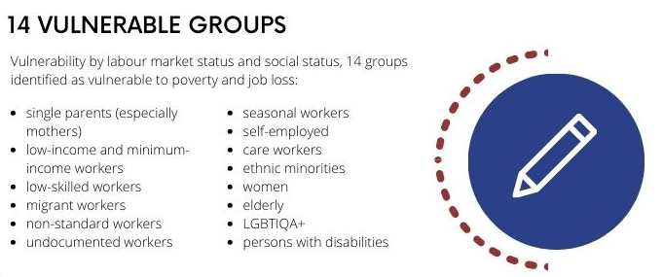
Source: the DEFEN-CE research team
Vulnerability was strongly linked to certain sectors and working conditions during the pandemic.
Overall, the COVID-19 pandemic had a profound and far-reaching impact on vulnerable worker groups across various sectors and industries. In this way, the COVID-19 pandemic elevated a new understanding of vulnerability among the workers. During the first wave of the pandemic, particularly essential workers, those working on the frontline, were seen to be particularly vulnerable due to the high medical risks that they faced in their work that could not be done remotely. These includes health and care workers and workers in food production, retail, security, cleaning and sanitation, transport and in manual and technical occupation. At the first wave of pandemic, they lacked protective gears, for instance respiratory protective equipment (RPE), that drove substantial risks for many groups of workers. Yet, even among these groups of workers, there were inequalities between sectors.

The DEFEN-CE database of policy measures

The DEFEN-CE project produced a Database of policy measures to safeguard vulnerable groups in Europe's post-COVID-19 labour markets through in-depth research and expertise.
The database encompasses 27 EU countries, Turkey, and Serbia, offering insights into policy measures addressing the pandemic's spread and its economic repercussions on diverse population segments. It delves into the involvement of social partners in crafting these policies and their approaches toward vulnerable groups. Additionally, the Database systematically reports social dialogue initiatives across the studied countries that were part of bringing forth COVID-19 responses to protect vulnerable groups. The database collected information on the measures adopted, the key priorities and strategies of social partners, and the predominant method they tried to achieve the policy was adopted.
The collected data offers a comparative, time-sensitive overview across countries, serving as a comprehensive resource for national qualitative studies. Through scrutinizing 853 policies enacted across the EU-27, Turkey, and Serbia from 2020 to 2022, we gained insight into the policy types implemented, the targeted demographics, and the involvement levels of social partners in policy adoption. During the pandemic, the primary emphasis was on preserving employment and the economy, reminiscent of strategies during the 2007-2008 financial crisis. Consequently, predominant measures included income support schemes and industry-specific subsidies, primarily directed towards workers and certain employment-based groups. However, vulnerable groups already at risk pre-pandemic were not equally addressed by these policies.
As the pandemic unfolded, some countries began instituting more specific measures, like programs tailored for youth or additional funding for those excluded from general protective policies (see Figure 2). For instance, measures in the arts and entertainment sector included tax relief for non-standard workers like food delivery personnel.
Figure 3 The DEFEN-CE database at a glance
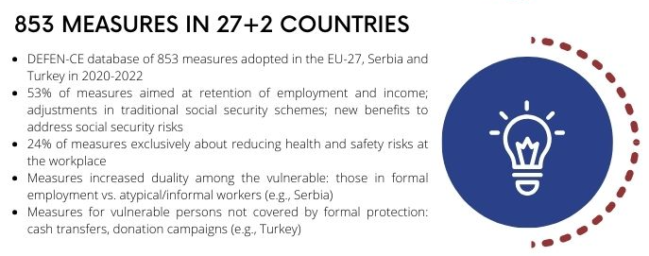
Source: the DEFEN-CE research team
Initially, numerous policies were implemented during the pandemic's early phase, enduring approximately a year despite subsequent waves and virus mutations. Yet, as vaccines became more accessible to larger populations, the number of measures decreased, signalling effective control of virus transmission.
Around half of policy adoptions were influenced or initiated by social partners, dependent on decision-making mechanisms and regulations tied to tripartite and bipartite negotiations (see Figure 4). Social partners employed diverse strategies like consultations, dialogues, and media campaigns during the pandemic. The findings revealed that almost half of the 853 policies were influenced by social partners, with employers having a say in 47% and trade unions in 45%.
Figure 4 Social dialogue in adopting national policy measures to protect vulnerable groups in the labour market
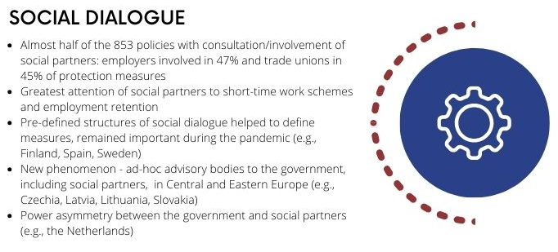
Source: the DEFEN-CE research team
However, other actors, like civil society organizations or professional associations lacking representation in decision-making, relied on advocacy and lobbying instead of direct dialogue. Professional associations, chambers, and other civil society organisations were responsible for 14% of the policies.
Despite constraints in the DEFEN-CE Database's coverage and data availability, its analysis sheds light on pandemic responses and how social partners wielded influence. It highlights the policy emphasis on general workers, overlooking connections between employment, ethnicity, migrant status, and amplified health risks, failing to enact more targeted protective measures for vulnerable individuals.
A crucial takeaway is that the predominant policy focus on preserving employment and the economy overlooks nuances linking employment status, ethnicity, family, and heightened health risks. This oversight results in policymakers neglecting specific measures needed to safeguard individuals facing multiple vulnerabilities.

Social dialogue in protecting vulnerable groups: EU-level strategies and responses

At the EU-level, the research team of the DEFEN-CE project conducted desk research and 11 interviews, revealing a spectrum of policies at the EU level, notably the EPSR, SURE instrument, RRF, and Directive on adequate minimum wages. These measures, primarily top-down, aimed to manage the unforeseen situation. However, their implementation at the national level exhibited substantial cross-national variations. SURE, especially, was acknowledged as an innovative social policy response by the European Commission.
Identifying vulnerable groups during the COVID-19 crisis was a central concern. While classic groups - aligned with the European Commission's definition of vulnerability tied to poverty and social exclusion - were severely affected, lessons highlighted broader social, economic, and health-related risks impacting different workers and employment sectors.
The pandemic profoundly impacted traditional and non-traditional social dialogue concerning working conditions and precariousness of work. The importance of social dialogue in addressing worker well-being issues became evident, unveiling vulnerabilities in working conditions and the necessity for inclusive negotiations among stakeholders.
Regarding the precariousness of work, the pandemic magnified challenges faced by unemployed individuals seeking alternative employment, especially those with multiple contracts. The crisis exposed shortcomings in protecting precarious workers, emphasizing the need for enhanced regulations and support programs.
Trade unions played a pivotal role in advocating for vulnerable workers, shedding light on issues faced across various sectors. Additionally, the pandemic prompted discussions on occupational health in social dialogue, showcasing its evolving nature.
The pandemic also underscored the need to reconcile work and family life, highlighting concerns about mental well-being, telework challenges, and the right to disconnect. Negotiations at the European level sought to regulate telework, emphasizing the role of social partners in addressing these emerging issues.
Looking ahead, emerging trends like the platform economy and digital-age work will continue shaping discussions at the EU-level on platform work, telework, and work-life balance, warranting an analysis of gender roles in these evolving work environments.

Social dialogue in protecting vulnerable groups: country-level responses

The country-level comparative analysis utilizes various industrial relations systems across Europe, including 10 EU Member States and two candidate countries. This section summarizes the key findings across the studied country pairs and two candidate countries. Each of these findings has been elaborated in detail in dedicated country reports within the DEFEN-CE project.

Baltic neoliberalism: Latvia and Lithuania

The impact of COVID-19 on Latvia and Lithuania's labor markets was profound, affecting both traditional and newly vulnerable groups (see Figure 5). The repercussions were notably similar in both countries, leading to decreased employment, altered working conditions, and reduced incomes for many workers. The key effects mentioned by national interviewees included worsened working conditions due to mask mandates, reduced workforce due to distancing requirements, sector suspensions impacting work intensity, and the sudden shift to remote work, leading to winners and losers in the workforce.
Measures taken by both nations were predominantly focused on income support, covering various groups such as employees, self-employed individuals, and workers in specific sectors. While most measures were deemed relevant for vulnerable groups, some received mixed reviews. In Latvia, social partner-initiated ideas for measures but did not hold primary decision-making power, using coalitions to influence outcomes effectively. Lithuania experienced less social partner involvement, particularly with employers being more active than trade unions in shaping policies.
Latvian social partners saw diminished influence within official structures due to slow decision-making processes, resorting to lobbying, media presence, and joint actions for more impact. Lithuania exhibited a clear divide between COVID-19 discussions and traditional social dialogue issues within the Tripartite Council. EU-level strategies formed a framework for national policies, drawing input from business and non-governmental organizations.
Figure 5 COVID-19 and industrial relations in Latvia and Lithuania
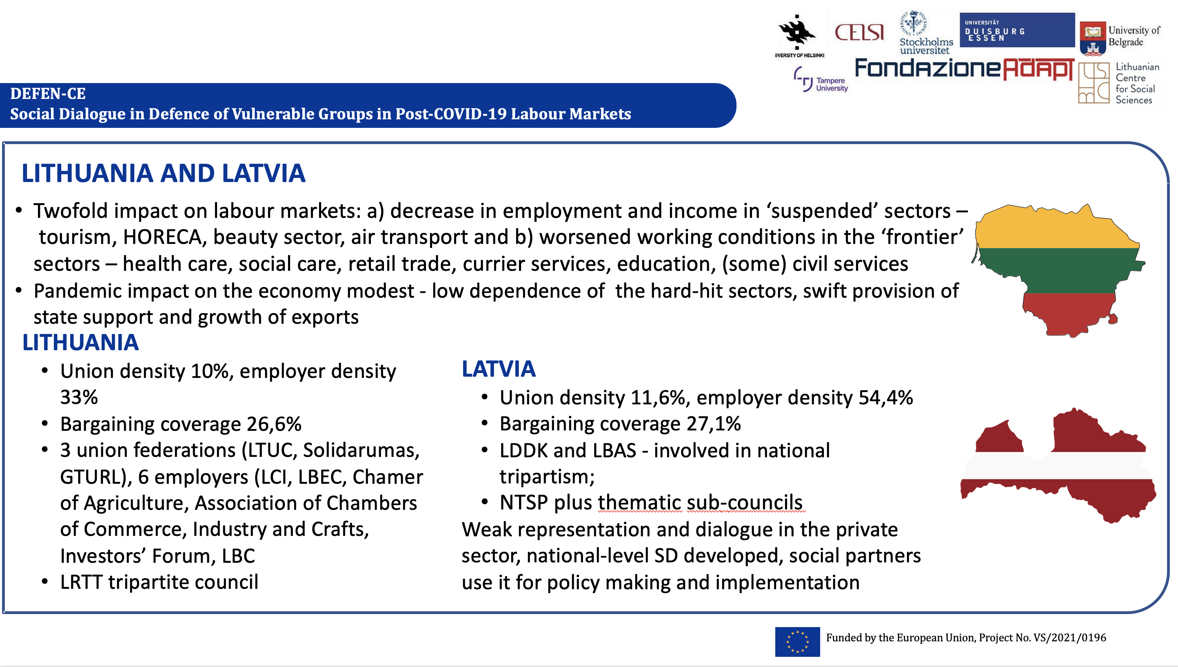
Source: ICTWSS Database and Blaziene et al. (2023)
Social partners in Latvia generally supported the measures, whereas in Lithuania, doubts were expressed regarding their appropriateness and effectiveness. Their involvement significantly shaped their perception. Both countries lacked established guidelines for social partners' roles during crises, heavily influenced by ruling coalitions' attitudes and stakeholders' proactive involvement.
While social partners' engagement varied, their timely involvement in decision-making was deemed crucial, strengthening social dialogue, fostering cooperation, and enhancing crisis response effectiveness. Both Latvia and Lithuania demonstrated that crises could be opportunities for social partners to achieve their objectives and improve social dialogue.
In sum, social partners engaged in mitigating the negative impacts of COVID-19 by participating in newly established structures rather than following traditional formats in both Latvia and Lithuania. Most social partners interviewed viewed social dialogue as a powerful tool in managing crises effectively. A realistic and timely engagement of social partners in decision-making processes bolsters social dialogue, nurtures collaboration (including with NGOs), and builds mutual trust. Therefore, social dialogue has the potential to improve a country's anti-crisis measures.

Continental Western Europe: Germany and the Netherlands

In Germany and the Netherlands, the pandemic intensified existing structural vulnerabilities, especially within industries dominated by low wages, part-time jobs, and temporary agency work, showcasing a divided labor market structure (see Figure 6). The pandemic, while having a less striking impact on Germany and the Netherlands' labour markets, unveiled a distinct dichotomy in their social dialogue structures and labour market conditions.
Both countries primarily aimed to safeguard their core sectors during the pandemic's onset, relying on established income protection measures like short time work to prevent widespread job losses. Social partners played a pivotal role in crisis management, contributing to cooperative crisis resolution within industries and companies. However, these measures addressed vulnerabilities unevenly, leaving certain groups exposed.
Traditional vulnerable groups, distanced from the labour market, faced challenges due to restrictions and economic shocks, hindering their employment opportunities. Workers in flexible segments, like solo self-employed or seasonal workers, lacked social security coverage and faced

Figure 6 COVID-19 and industrial relations in Germany and the Netherlands
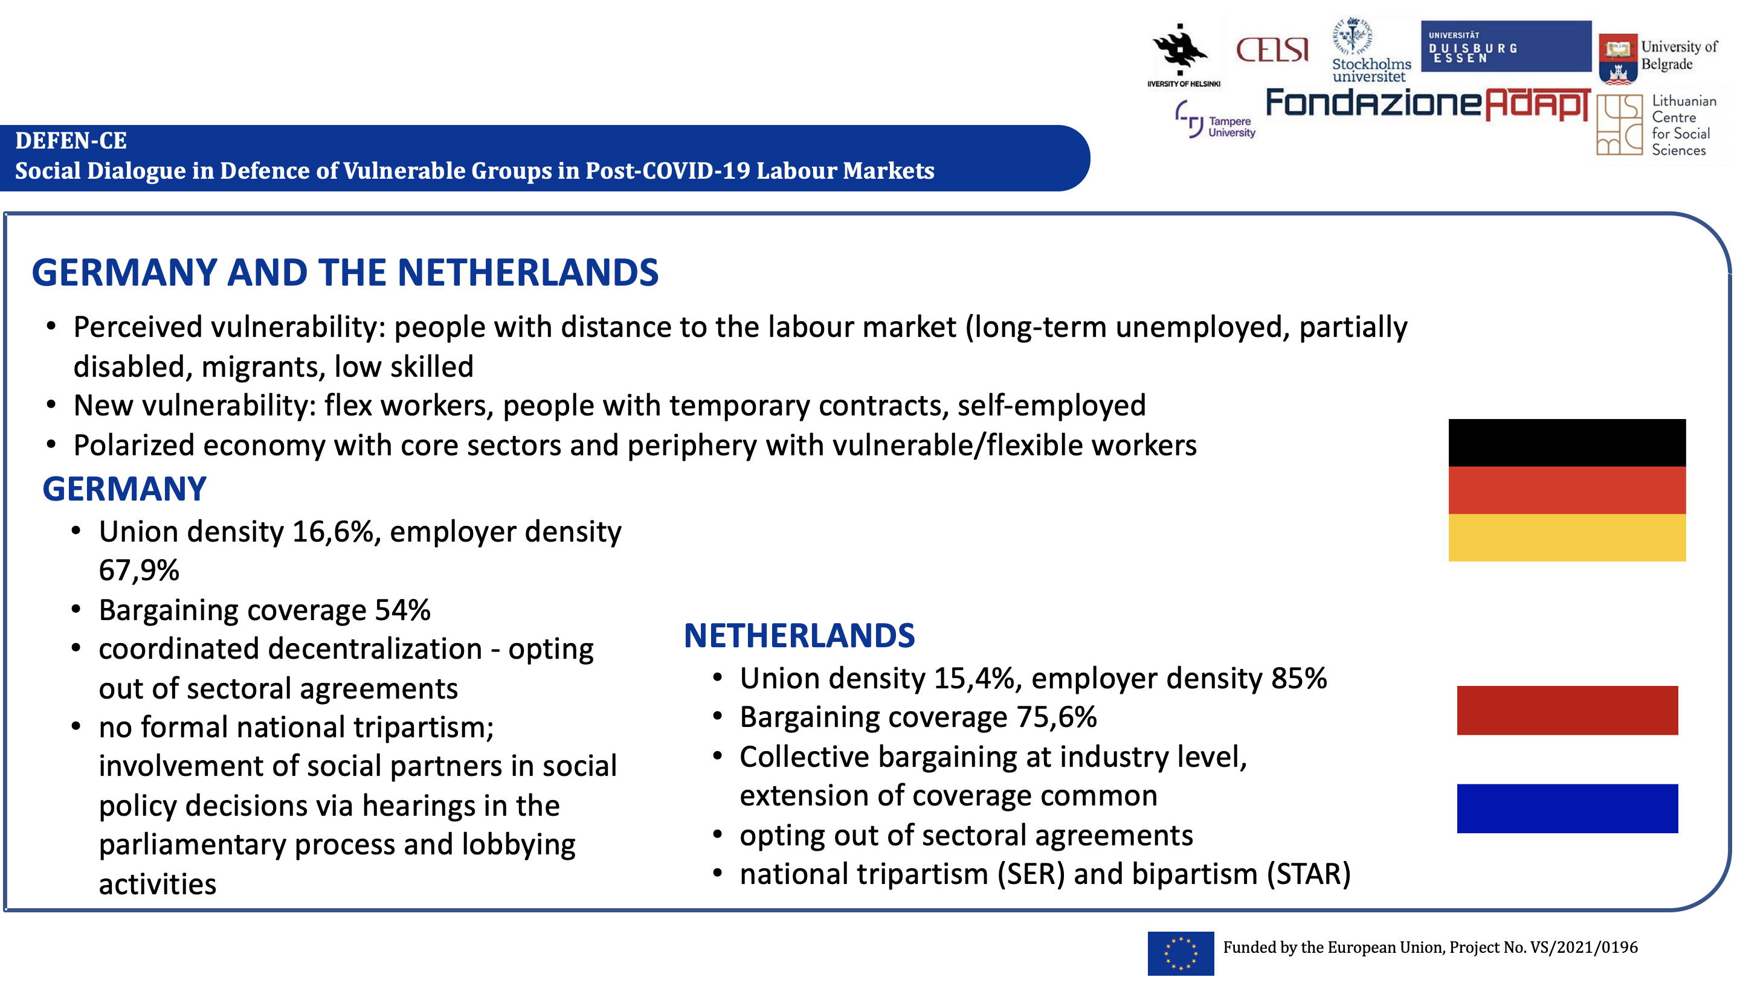
Source: ICTWSS Database and Jaehrling et al. (2023)
economic vulnerability. Sectors such as agriculture and eldercare saw the intersection of economic and health vulnerabilities, particularly in essential worker roles. Indirect vulnerabilities arose from pandemic-related measures, impacting parental care burdens and disrupting public employment services.
Policies addressing vulnerabilities aligned with two models: a conservative approach and an innovative approach. The conservative strategy maintained existing policy instruments, benefiting primarily established labor markets and inadvertently overlooking workers in peripheral industries. In contrast, the innovative model led to sector-specific reforms, particularly in essential worker domains like agriculture and eldercare, driven by newly formed or bolstered tripartite platforms. Germany displayed such innovation, introducing reforms to protect essential workers and prolonging certain exceptional measures from the pandemic era.
Germany's citizens' benefit reform and the EU's focus on vulnerable essential workers indicate potential long-term impacts of the pandemic. While the citizens' benefit seeks to address structural inequalities, there's a need for further research to assess its effectiveness. Additionally, the EU's social conditionality in agriculture aims to ensure fair working conditions, reflecting a shift towards more socially just labor regimes.
The pandemic's lasting effects on social dialogue and vulnerability in labor markets necessitate continued investigation. However, the study highlights the buffering effect of social dialogue and robust social security arrangements in Germany and the Netherlands during the crisis. It also underscores the importance of social dialogue beyond income replacement, emphasizing the need to address working conditions, health, safety, and equality to enhance societal well-being.
In sum, in the Netherlands the alignment of social partners' values led to a strong focus on vulnerable groups, reflected in policies addressing their needs. The country's longstanding tradition of social dialogue facilitated swift and adaptable negotiations, even amidst the pandemic. The government's willingness to inject substantial public funds (80 billion EUR) to sustain the economy diverged from traditional bargaining practices in resource-scarce situations. Dialogues predominantly centered around ensuring scheme coverage, advocating for the inclusion of pertinent topics of interest.
Meanwhile, Germany witnessed sector-specific engagement by social partners in pandemic governance, leading to innovative and lasting solutions. The pandemic served as a testing ground for structural changes, resulting in notable regulations such as the prohibition of subcontracting and temporary agency work in meat processing, mandatory health insurance for seasonal agricultural workers, and improved nurse-to-patient ratios in elder and healthcare via novel monitoring methods.

Embedded neoliberalism: Czechia and Slovakia

Both Czechia and Slovakia experienced economic decline and modest unemployment rises during the pandemic. Vulnerable groups like single working parents, precarious workers, and those with low income faced heightened job loss and poverty, with marginalized Roma communities especially affected, facing discrimination in pandemic-related policies (see Figure 7).

Figure 7 COVID-19 and industrial relations in Czechia and Slovakia
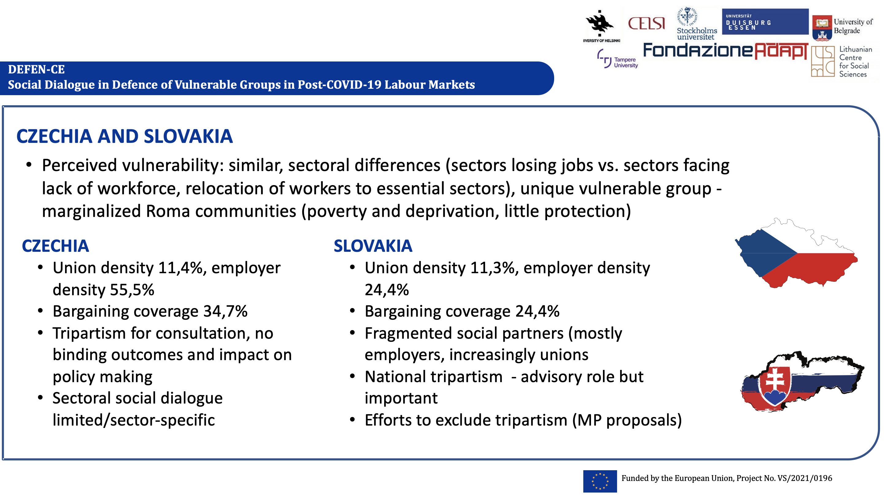
Source: ICTWSS Database and Kahancová et al. (2023)

No specific policy measures targeted vulnerable groups while the adopted measures focused broadly on employment protection. Adjustments were made later to include excluded groups, but uptake among vulnerable groups was low due to stringent conditions. Slovakia introduced specific measures for the Roma community, more focused on health than labour market protection.
Social partners lacked a focus on labour market discrimination faced by marginalized communities. Their influence primarily affected broader labour market measures rather than specifically targeting vulnerable groups. NGOs had more impact via media but operated outside established channels where social partners were involved.
Both countries showed similar social partner structures and engagement patterns. Slovakia had more established collective bargaining, impacting national measures during the pandemic, unlike Czechia, where social partner involvement in national measures affecting collective bargaining was not highlighted.
Social partners in both countries saw increased legitimacy in accessing COVID-19 decision-making but had a neutral long-term impact on formalized channels like tripartite social dialogue. While unions and employers converged on employment protection, vulnerable groups were represented mainly by NGOs, lacking policy access.
Regarding policy implications, ad hoc advisory bodies challenged established social dialogue initially but did not affect long-term structures. Social dialogue remained stable, but a shift toward individual lobbying activities by peak-level social partners was observed, without a substantial impact from the pandemic.
In sum, while initial challenges to established structures were seen, long-term impacts on social dialogue due to the pandemic were limited, and structures remained stable. Social partners maintained their involvement in established tripartite committees, emphasizing their long-standing legitimacy. In Czechia, social partners initiated the recognition of Covid-19 as an occupational disease. Short-time work schemes aimed at job retention were considered a significant achievement. In Slovakia's metal sector, these schemes activated collective bargaining. The perceived legitimacy of social dialogue as a governance mechanism remained unaffected by the presence of ad-hoc advisory bodies. NGOs, public employment services, and government representatives, such as the plenipotentiary, played crucial roles. For instance, marginalized Roma communities faced violations of their labor-related rights as pandemic protection measures were not universally applied, including issues like workplace access. These concerns extended beyond the interests typically represented by trade unions.

Nordic corporatism: Finland and Sweden

The analysis on COVID-19 responses to protect vulnerable groups in the labour market and the role of social dialogue therein reveals a remarkable predictability in the actions of social partners within the Finnish and Swedish labour markets during the COVID-19 crisis. Despite differing health and safety approaches, both Nordic countries responded similarly in safeguarding vulnerable groups, showcasing strong institutional path-dependency tied to historical institutionalism. The established structures of social dialogue granted central roles to traditional partners but also hindered other organizations' recognition, creating an insider-outsider dilemma (see Figure 8).
Figure 8 COVID-19 and industrial relations in Finland and Sweden
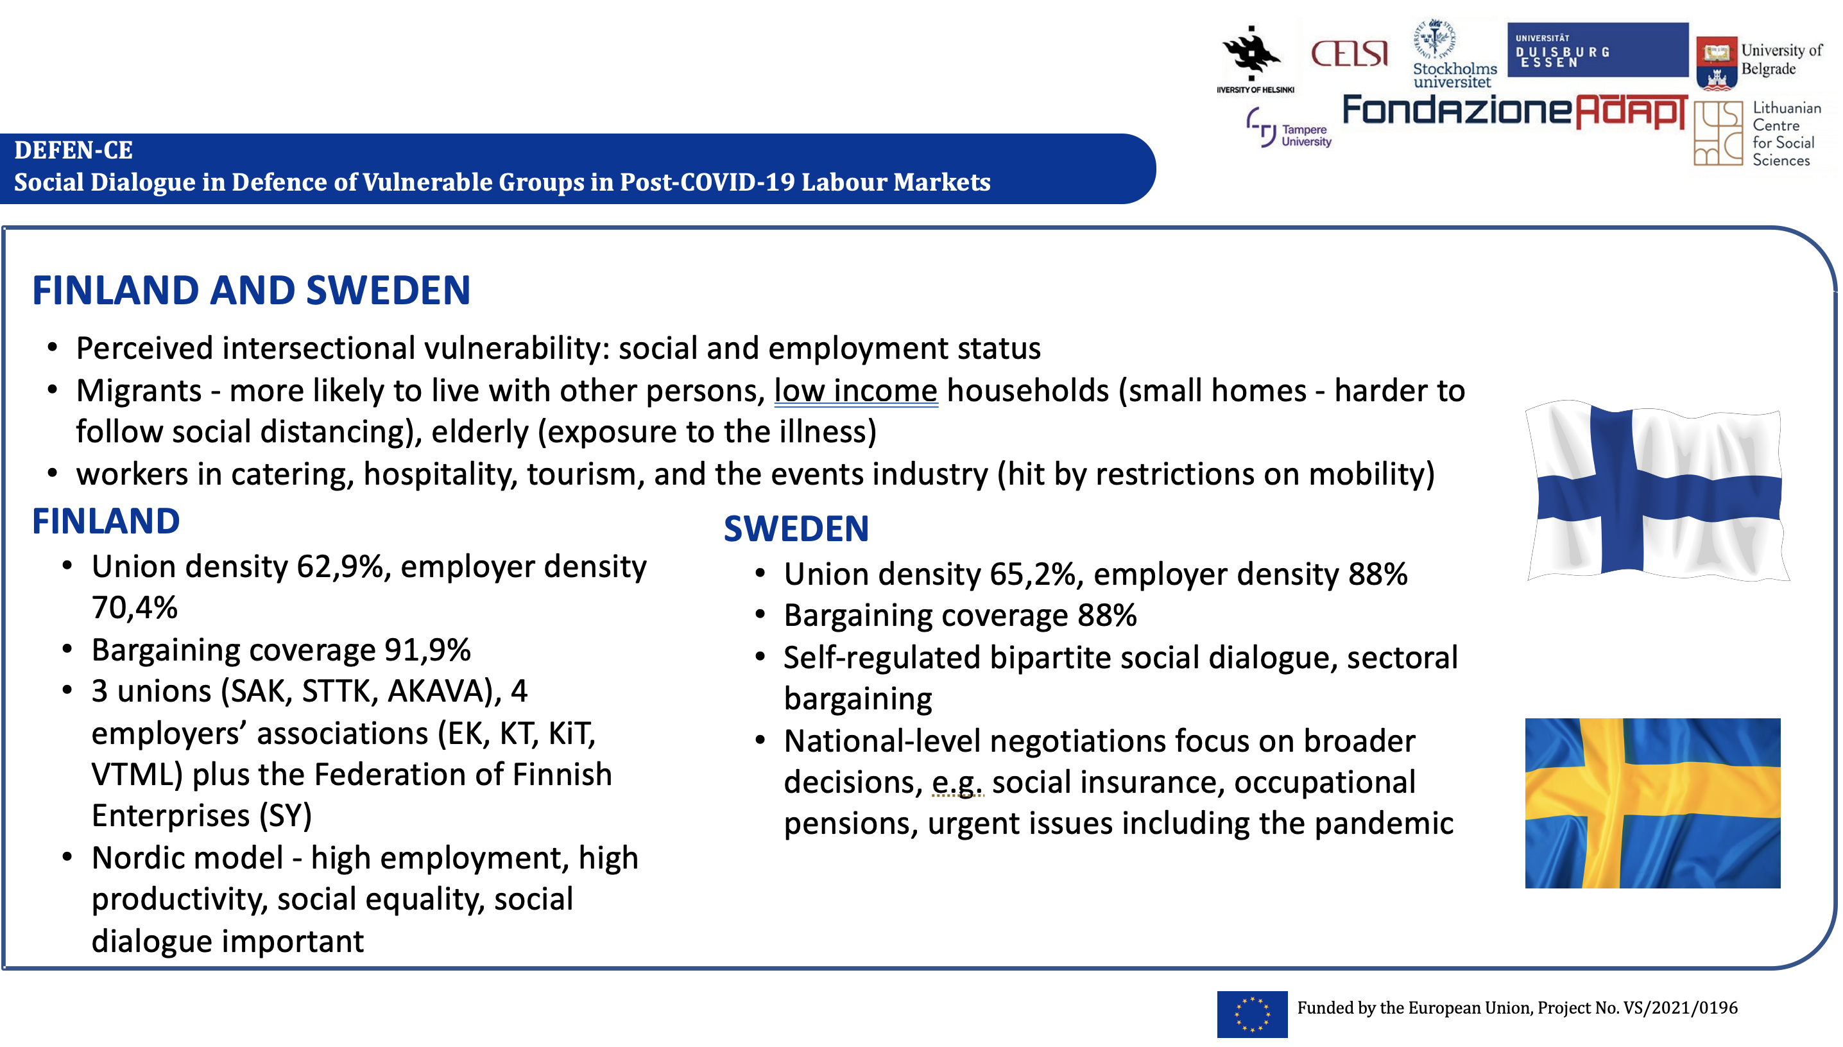
Source: ICTWSS Database and Strigén et al. (2023)
Yet different roles of social dialogue were uncovered. Finland adopted rigorous mitigation strategies to safeguard the elderly and avert healthcare system overload. In contrast, Sweden relied on individual responsibility, encouraging citizens to maintain social distance, work remotely, practice hand hygiene, and limit travel voluntarily. The situation illustrates an insider-outsider dilemma involving traditional social partners and civil society actors.
While most sectors displayed collaboration, conflicts arose in the pressured care sector, revealing disparities in power resources. The dynamic industrial relations and public-private sector issues influenced these conflicts. Unions naturally addressed vulnerability as integral to their existence, while employers' organizations often hesitated to discuss it, reflecting divergent purposes between the two groups.
The lasting impacts of COVID-19 remain uncertain, with policies mostly seen as temporary adjustments rather than substantial changes in social protection systems. Despite Sweden and Finland's divergent health strategies, social partners' experiences were notably similar, suggesting that historical institutional structures might have influenced responses to public health measures and measures protecting vulnerable groups.
This finding underscores the need for further investigation into the intricate relationship between historical institutional structures and the responses of social partners in crisis situations. The findings show that in both countries, the functioning of social dialogue remained largely consistent during the pandemic. This is indicative of institutional path dependency, showcasing the efficacy of the Nordic model. Well-established structures in industrial relations and social dialogue naturally positioned social partners at the forefront during crises.

Southern social dialogue model: Italy and Spain

Resembling the ‘Southern’ type of industrial relations with some degree of decentralization and at the same time an important role of (central and local) government, Italy and Spain show some differences in their industrial relations landscape as well as in their approach to essential sectors during the pandemic (see Figure 9).
Figure 9 COVID-19 and industrial relations in Italy and Spain
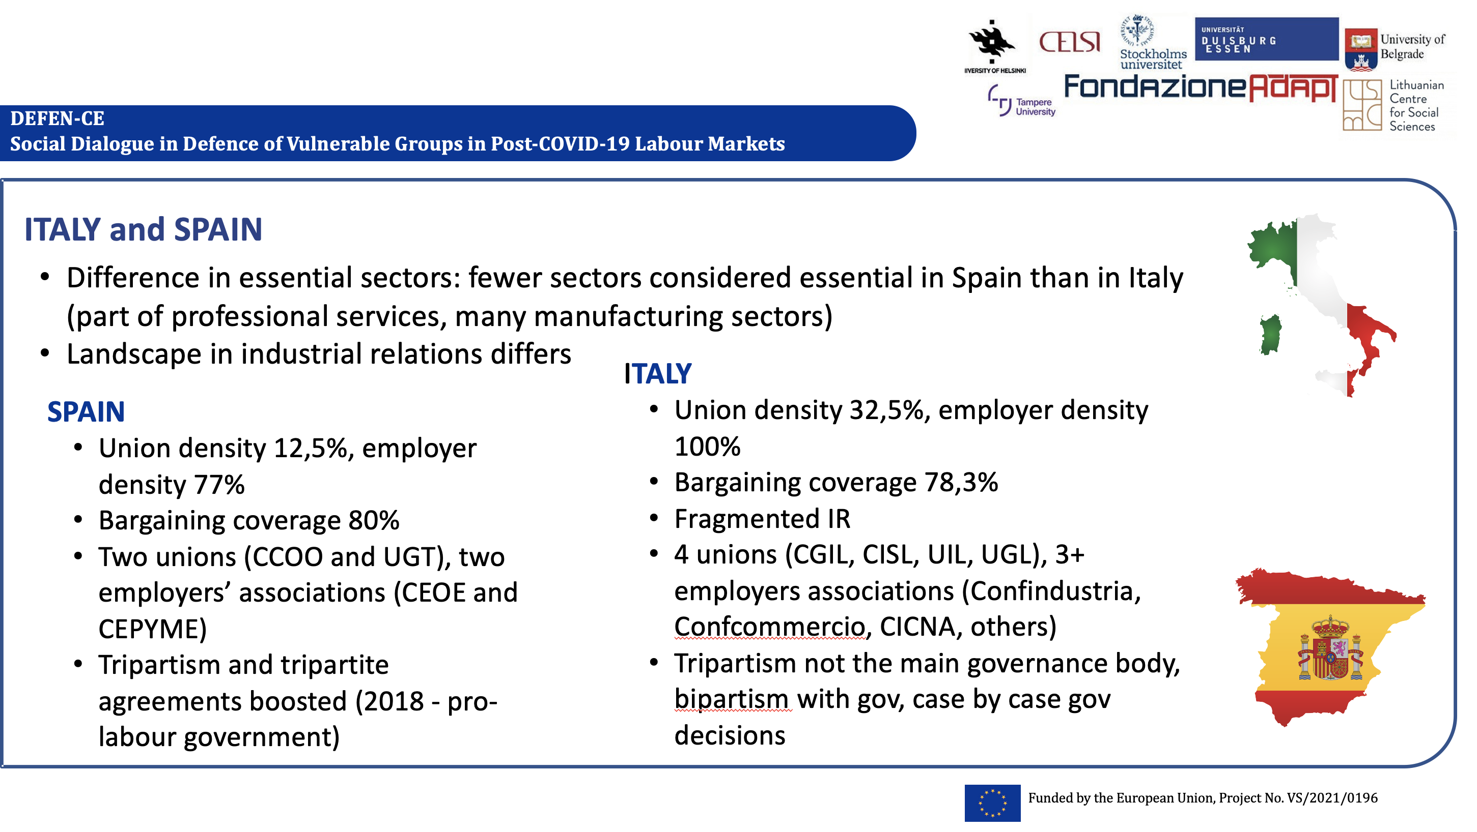
Source: Seghezzi et al. (2023)
The analysis revealed that vulnerable groups, encompassing women, migrants, individuals with non-standard employment arrangements, the self-employed, and those with lower education and
income levels, bore the brunt of COVID-19's labor market impact. Italy and Spain implemented similar measures, focusing on income support and job protection for these vulnerable groups.
The role of social partners varied in both countries. Italy's partners had limited involvement in policymaking beyond consultation, except for negotiations on health and safety protocols. Conversely, Spanish partners actively engaged in tripartite negotiations, resulting in agreements addressing unemployment benefits and income support. Spain's continuity in governance enhanced partner collaboration, while Italy faced political shifts and challenges in collective action.
In Italy, the involvement of social partners in safeguarding vulnerable groups was more evident, seen through pressures exerted via social media, the establishment of numerous bilateral measures, and the development of the Health and Safety Protocol. However, their role primarily remained consultative, with final decisions resting at the discretion of the government.
In Spain, social partners actively and significantly contributed to shaping protective measures, working alongside a government that welcomed their input. This involvement encompassed negotiations and collaboration with various stakeholders to devise holistic solutions for both the
workforce and the broader economy. Similarly, Spain banned dismissals, expanded eligibility for benefits, and implemented income schemes. Spain showcased stronger social partner legitimacy due to active engagement, resulting in the continuation of formal social dialogue. Italy's social partners struggled post-pandemic, diminishing their influence and formal channels.
In both countries, lessons highlighted the importance of social dialogue and active partner involvement, underscoring their legitimacy's pivotal role in policy effectiveness. Government responsiveness impacted partnership effectiveness, seen more favorably in Spain than Italy.
In sum, the pandemic acted as a catalyst in reviving social dialogue, yet the manner of restoration differed between Spain and Italy. Spain had a history of relevant tripartism, marked by multiple tripartite agreements following the 2008 crisis. Conversely, in Italy, tripartism wasn't regarded as a crucial governance mechanism by governments, a stance that persisted during the pandemic. Prioritizing social dialogue, bolstering partner roles, and improving government responsiveness remained pivotal for crafting inclusive policies that cater to vulnerable groups during crises and beyond. These insights are vital for policymakers and stakeholders aiming for more effective and inclusive strategies.

Candidate country - Serbia

The COVID-19 crisis marked an extraordinary period for Serbian society and social dialogue actors. Its long-term impact on social dialogue and vulnerable groups' protection remains uncertain, making it a potential turning point in their development, but its true significance might only be discernible in hindsight.
In Serbia, the pandemic brought significant disruptions to the economy, particularly impacting the labor market (see Figure 10). State interventions, like minimum wage subsidies for job retention and tax payment deferrals, softened the blow to some extent.
However, the protective measures primarily shielded formal employees with indefinite contracts, leaving others, like those with fixed-term or informal employment, less secure. Businesses
Figure 10
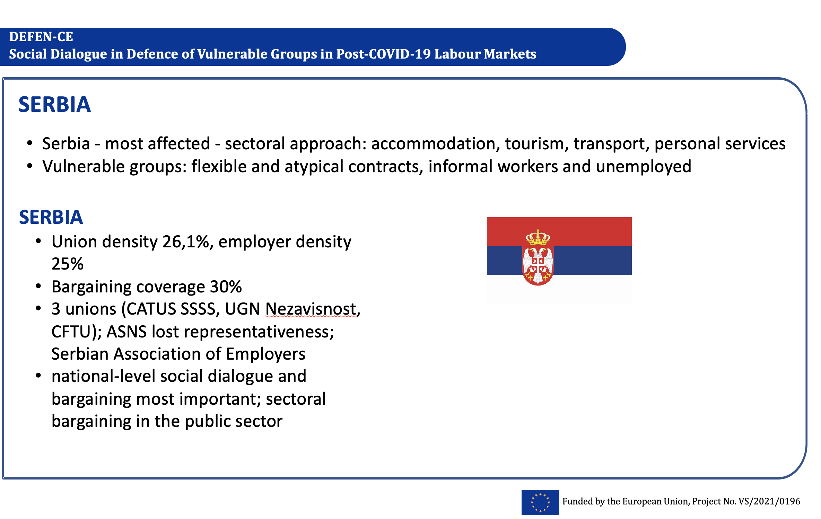
Source: Arandarenko and Aleksić (2023)

grappling with pandemic-induced challenges tended to reduce atypical and informal employment, relying on broad economic policies to support demand and indirectly safeguard overall employment levels, rather than safeguarding individual positions.
While additional measures targeted hardest-hit sectors, their effectiveness in protecting employees with atypical contracts or those in the informal sector was limited. Vulnerable workers, especially those without stable employment, faced challenges exacerbated by their lack of union membership.
Moving forward, unions should focus on these vulnerable groups, forging alliances or providing resources and guidance for their self-organization. Despite challenges, there was an uptick in solidarity and cooperation among stakeholders during the crisis.
Although valuable lessons emerged, the power balance and attitudes among actors haven't shifted as anticipated during the height of the pandemic. Social dialogue has swiftly returned to normal in certain aspects.
In sum, the preservation of jobs in private sector firms was facilitated through direct subsidies, involving a flat-rate payment equivalent to a net minimum wage for each full-time employee. The impact of social partner initiatives on adopted measures was notably minimal, particularly concerning the protection of vulnerable groups.
A crucial lesson gleaned from the pandemic is the necessity for increased solidarity, mutual recognition, and trust among social partners to effectively balance the power dynamics and interests among actors engaged in social dialogue.

Candidate country - Turkey

Turkey's already fragile labour market and industrial relations system were further strained by the COVID-19 pandemic, amplifying its negative impact on vulnerable groups and limiting the effectiveness of social partners in crafting appropriate policies (see Figure 11). Although there was consensus among social partners regarding socially and economically vulnerable groups, varying
Figure 11
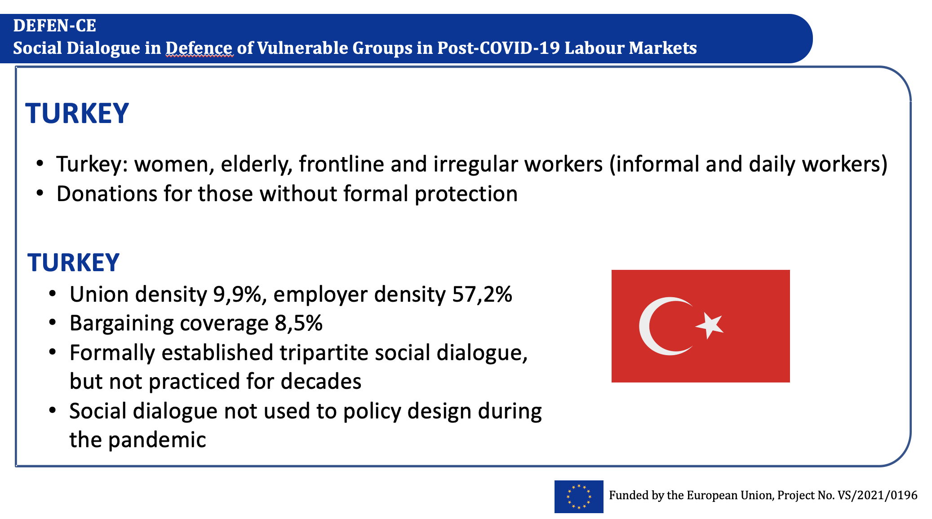
Source: Duman (2023)

levels of importance were assigned to each category. The elderly and those with health issues were identified as high-risk groups, and measures aimed at their protection were generally viewed positively, despite their adverse effects on the labor market, which were largely unaddressed by the government.
Women, youth, and irregular workers, including informal and daily wage employees, faced heightened vulnerability before, during, and after the pandemic in the Turkish labor market. Social policies targeting these groups were deemed insufficient, prompting some social partners to supplement them for their members. Additionally, digital disparities in online education posed a significant challenge for the youth. Sectoral differences were highlighted, particularly affecting small firms lacking digital capabilities for remote work and service industries hit hardest by the pandemic. Notably, the exclusion of refugees from vulnerability discussions reflected an insider-outsider view, as they are predominantly employed in the informal sector without representation from trade unions or employer organizations.
Assessing the effectiveness of social dialogue mechanisms revealed conflicting perspectives among social partners. While certain trade unions and all employer organizations claimed a robust social dialogue enabling policy influence through information exchange and lobbying, most trade unions, NGOs, and some professional association strongly contested this view. They argued that policy decisions were centralized without consultation. Some partners emphasized the role of digital tools in legitimizing their positions as social actors, raising awareness about overlooked policy areas and risks. Despite differing views on the success of social dialogue during the pandemic, inclusiveness and institutionalizing mechanisms were universally acknowledged as crucial by all partners.

Conclusions

In sum, the DEFEN-CE project showed that vulnerable groups resemble similarities across countries, with vulnerability linked to both labour market status and social standing. Varying perceptions of vulnerability emerged, particularly regarding essential versus non-essential sectors. Social dialogue retained significance as a governance mechanism yet was influenced by institutional path-dependency. National social dialogue witnessed no significant advancements or innovations. Stability prevailed, notably in the existence of ad hoc government advisory bodies and committees in Central and Eastern Europe.
To summarize the findings of this multi-dimensional, multi-level and multi-purpose research project, Figure 4 shows that limited exclusive COVID-19 protections for vulnerable groups has been observed across the EU. Social partner engagement in these measures was strongly linked to pre-pandemic standards and modes of operation of dialogue and negotiations. Restoration of social dialogue in most countries occurred with minimal innovation. In certain cases, i.e., Spain, enhanced social partner legitimacy was documented. Next, the pandemic marks social dialogue's significance but at the same time the research acknowledged missed chances for advancements in established social dialogue procedures. Innovative pandemic responses via social dialogue were recorded in some countries, e.g., through sector-specific strategies in Germany's agriculture. Finally, some evolution in social dialogue topics has been observed, such as the inter-sector mobility and new work structures in the Netherlands. Finally, personal connections were utilized to gain access to the government in Turkey.

Figure 12 Lessons from the DEFEN-CE project
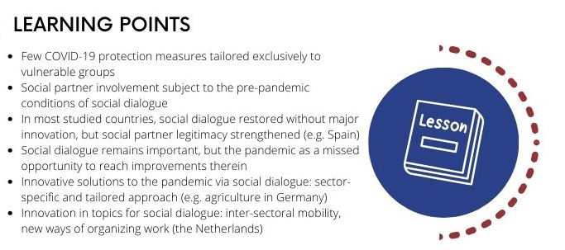
Regarding the question about activating more social dialogue at the national level within the European framework regulation, the project ends with a relevant question that is subject to further research: How might the European framework regulation be leveraged to enhance and encourage improvements in social dialogue at the national level?

References

Arandarenko, M., and Aleksić, D. (2023). DEFEN-CE Country Report: Serbia [Report produced within the DEFEN-CE project, project no. VS/2021/0196].
Blaziene, I., Karnite, R. and Moskvina, J. (2023). DEFEN-CE Comparative Country Report: Latvia and Lithuania [Report produced within the DEFEN-CE project, project no. VS/2021/0196].
Boonjubun, Ch., Singh, G. and Van Gerven, M. (2023). Defending vulnerable groups and the role of social dialogue at the EU-Level [Report produced within the DEFEN-CE project, project no. VS/2021/0196].
Choonara, J., Murgia, A., and Renato Miguel Carmo, R.M. (eds.) (2022). Critical Perspectives on Precarity and Precariousness. Bristol: Bristol University Press.
Duman, A. (2023). DEFEN-CE Country Report: Turkey [Report produced within the DEFEN-CE project, project no. VS/2021/0196].
European Commission (2010) Inclusion of vulnerable groups, http://ec.europa.eu/employment_social/2010againstpoverty/extranet/vulnerable_groups_en.pdf (retrieved 5 June 2020).
Hall, P. (1997). The role of interests, institutions, and ideas in the comparative political economy of the industrialized nations. In M. Lichbach & A. Zuckerman (Eds.), Comparative politics: Rationality, culture, and structure (pp. 174–207). Cambridge University Press.
Hall, P., and Taylor, R. (1996). Political Science and The Three New Institutionalisms. Political Studies, 44(5), 936–957
Holubová, B. and Kahancová, M. (2024). Understanding Vulnerability: A Theoretical and Conceptual Framework [Report produced within the DEFEN-CE project, project no. VS/2021/0196].
Jaehrling, K., Lluis, C., van Gerven, M. and Salmi, A. (2023). DEFEN-CE Comparative Country Report: Germany and The Netherlands [Report produced within the DEFEN-CE project, project no. VS/2021/0196].
Kahancová, M., Brunnerová, S., Holubová, B. and Martišková, M. (2023). DEFEN-CE Comparative Country Report: Czechia and Slovakia [Report produced within the DEFEN-CE project, project no. VS/2021/0196].
Kahancová, M., Meszmann, TT. and Sedláková, M. (2020). Precarization via Digitalization? Work Arrangements in the On-Demand Platform Economy in Hungary and Slovakia. Frontiers in Sociology, Vol. 26, 5:3, available at: Frontiers | Precarization via Digitalization? Work Arrangements in the On-Demand Platform Economy in Hungary and Slovakia | Sociology (frontiersin.org)
Korpi, W. (1989). Power, Politics And State Autonomy in the Development of Social Citizenship: Social rights during sickness in eighteen OECD countries since 1930. American Sociological Review, 54(3), 309–328.
Korpi, W. (2003). Welfare-State Regress in Western Europe: Politics, Institutions, Globalization, and Europeanization. Annual Review of Sociology (Vol. 29). Stockholm University, SOFI working paper 5.
O’Connor, J., and Olsen, G. M. (1998). Power Resource Theory and Welfare State. University of Toronto Press.
Scharpf, F. W. (1997). Games Real Actors Play. Actor-Centered Institutionalism in Policy Research. Westview Press.
Seghezzi, F., Serrani, L., Negri, S., and Virgili, V. (2023). DEFEN-CE Comparative Country Report: Italy and Spain [Report produced within the DEFEN-CE project, project no. VS/2021/0196].
Stiller, S., and van Gerven, M. (2012). The European Employment Strategy and National Core Executives: Impacts on activation reforms in the Netherlands and Germany. Journal of European Social Policy, 22(2), 118–132. https://doi.org/10.1177/0958928711433652
Strigén, J., Elmi, Z., Salmi, A., Nieuwenhuis, R. and van Gerven, M. (2023). DEFEN-CE Comparative Country Report: Finland and Sweden [Report produced within the DEFEN-CE project, project no. VS/2021/0196].

Views and opinions expressed are those of the authors only
and do not necessarily reflect those of the European Commission.
The European Commission cannot be held responsible for them.

