I want to work, who can help me?
Strengthening the cooperation between policy makers and the non-profit sector in return to work of persons with health conditions
CELSI Policy Brief No. 15

Holubová, B., Kahancová, M., Kováčová, L., Mýtna Kureková, L., Sedláková, M., Šumichrast, A., a Torp, S.
Central European Labour Studies Institute (CELSI), Slovak Governance Institute (SGI)
University of South-Eastern Norway (USN)

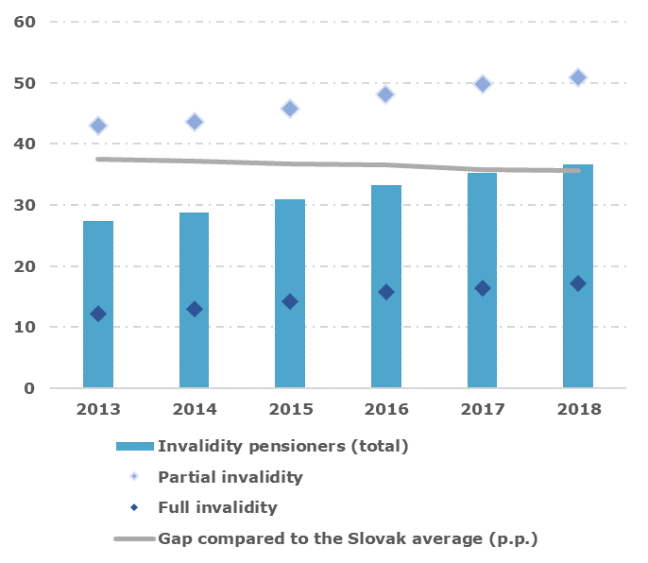 |  |  | 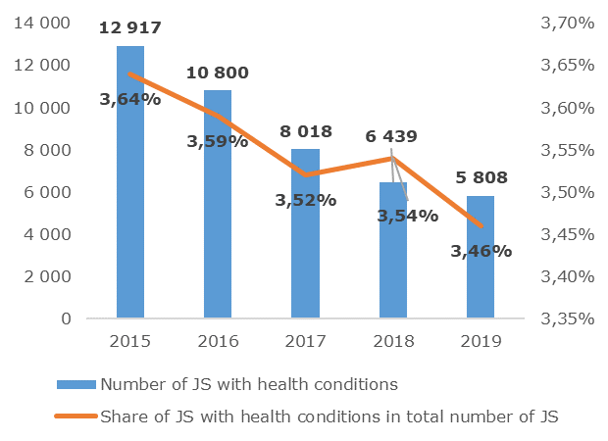
Graph 1: Development of the employment rate of invalidity pensioners (%)  Source: Revision of expenditures 2020, based on data from the Social Insurance Agency (ÚHP, IVP and ISP, 2020). |  |  | Graph 2: Number of registered job seekers (JS) with health conditions in Slovakia  Source: Centre for Labour, Social Affairs and Family
Problem Description
- Persons with disabilities (PwDs) (with an official and non-official status of persons with health conditions) form a significant part of the population but are currently facing exclusion in socio-economic integration  - Current data indicate a low rate of labour market attachment of PwDs when only a small proportion is economically active than the rest of the population (Graph 1.)  - In the labour integration on PwD, Slovakia lags significantly behind other EU countries. Young people aged 16-24 with disabilities show a meagre employment rate, which is confirmed by the weak interconnection of education to the labour market (Ondrušová, et al. 2017).  - Assessing the status of PwD is based on medical findings even though Slovakia refers to the UN Convention, which points out the variability of the concept of disability and its cultural conditionality  - Social and labour legislation concerning PwD is covered by a range of different legislative norms, which are not based on a uniform definition and concept of health conditions |  |  | - Persons returning to work after a long-term illness is absent in legislation and research. Their definition is missing, and their number is unknown; any labour market policies for this target group are now missing.  - Key policies for the integration of PwD, such as social enterprises and sheltered workshops, do not sufficiently support the transition of PwD to the primary labour market  - People with disabilities who find a job partly face precarious and unstable work  - Public employment services provide only a small amount to PwDs (Chart 2) and are not ready to work with applicants with multiple disadvantages, except for health conditions also with, e.g. ethnicity, age, gender or homelessness  - The absence of systematic data collection is a serious obstacle  to drafting and verifying the effectiveness of public policy in the fieldwork integration of PwDs  - Slovakia currently lacks systematic cooperation of social dialogue actors, but also patient organisations, with public or third-sector organisations supporting the integration of PwDs into labour market
The integration of people with disabilities into the labour market and their retention in the labour market throughout working life is a complex process that requires the cooperation of several actors at different levels.
Research Findings
Policies and tools | Roles of the actors | Implementation practice |  |  | Cooperation
International and framework documents  - UN Convention on the Rights of Persons with Disabilities, European Charter of Human Rights  - EU Strategy in the area of health conditions  - National Programme for the Development of Living Conditions of the Persons with Disabilities for the Years 2014 – 2020.  Key tools for persons with the formally granted status of PwD  - Labour market integration: increased labour law protection, quotas for compulsory employment of PwDs, sheltered workshops, social enterprises, labour office contributions to employers  - Return to work after sickness leave: social enterprises, sheltered workshops, company policies, trade union activities, employment office contributions to employers  Key tools for persons without formally granted status of PwD  - Labour market integration: support from state agencies and non-governmental organisations, career and psychological consultations, social enterprises  - Return to work after sickness leave: occupational rehabilitation, company policies (individual approach to PwDs, corporate health and safety commissions); trade union activities at the company level (consultancy, support, participation in occupational safety and health commissions, collective bargaining on the reduction of working time or change of work content, etc.) | Expected roles of actors  - Representatives of the state and institutions create policies, legislation, participate in its implementation, control, monitoring and data collection  - Representatives of non-governmental organisations directly support the integration of PwDs in the labour market and society, defend the rights of PwDs  - Trade unions represent the interests of employees, including PwDs in the labour market, participate in the creation of legislation, implementation practice, e.g. through collective  - Employers directly facilitate employment, resp. return to work of PwDs; some are interested in a workforce diversity strategy  Current role of actors  - The interviews showed that most of the organisations focus on the work integration of PwDs only marginally in addition to other competencies  - For 1/3 of the addressed organisations, work integration is the primary focus; the rest do not focus on the work integration of PwDs at all  - Despite that, from the description of their activities and implemented projects, it was clear that they have experience with PwDs work integration | Barriers of PwD integration  - Lack of skills, expertise, capacities, information integration of PWDs to labour market  - Pressure on performance, high working pace, keeping standard working procedures  - Prejudices against people with disabilities  Tools assessment  - Active market measures  are short-term, administratively demanding; educational activities are missing  - Sheltered workshops are  important, but support the transition to open market to prevent PwDs segregation is missing  - Social enterprises are  positive, the obstacle is  however, the interpretation of some paragraphs and problems with their implementation  - Contributions to PwDs employment are rather not motivating, and their real effect on the PwD employment is not known  - Voluntary and soft measures support in particular the socialisation of PwD and individual approach  - Mandatory quotas for PwD employment are according to unions the avoidance of employers´ obligations, for  Employers, the quotas are coercion; they demand to transfer the duty to the state  - The financing of job skills development is not targeted at PwDs, but for all job seekers |  |  | Current cooperation  - Despite the shortage of cooperation, informal networks were identified  between the actors  - The most common areas of collaboration are practical  help for specific PwD group, sharing information and experience; less in the area of legislation change  and collective negotiations  - Obstacles to the current  - cooperation is a lack of willingness to cooperate, personnel capacities, financial resources and information, competition for resources and legitimacy between NGOs  - Collaboration is supported by legislative framework, individual contacts, specific know-how, availability of financial resources and state support  Potential cooperation  - All types of actors see space and the need for cooperation improvement  - Areas of potential cooperation are the expansion of the collaboration with new actors and to neglected PwDs groups, intensifying existing cooperation, overcoming departmentalism, collective negotiation, sharing information and exchange of good practice and in  setting priorities at EU funds allocation
Comparison of approaches to integration of PwDs in Norway and Slovakia
Criteria | Norway | Slovakia
Target groups of PwDs, with the right to occupational rehabilitation and support of return to work | Inclusive approach; different subgroups of persons with disabilities; striving for everyone’s participation in the labour market | Policies and measures mainly relate to PwDs with the formally recognised status of seriously disabled persons, resp. disability pensioner
Overall approach to labour market integration of persons with disabilities | Central policies and measures are not directive; they define priority areas and delegate powers to employers; they frame cooperation but leave room for actors to implementation | Policies and measures in Slovakia are centralised and rather directive, partly motivating (financially, through fines)
Intermediate level of integration - sheltered employment | Does not exist; integration into the primary labour market is preferred; therapy, support, mentoring in the workplace are integral parts of it | Sheltered workshops and social enterprises are the main measures within the Slovak PwDs labour integration policy; integration into the open labour market is not systematically set
Specific central programs to support labour integration | Exist in the form of strategic long-term umbrella projects | Strategic only specific measures (e.g. social enterprises), otherwise ad-hoc, project-based and upon the willingness of particular people
Approach in state policy to labour integration | Philosophy of “First work, then integration”; Gradual return to work after chronic illness with therapeutic support | Philosophy of “First preparation for integration, then work”  There is a lack of a progressive and planned approach to work integration. It is more or less in the goodwill of employers
Employers´ responsibilities | Broad and formally granted powers, employers are full-fledged partners in all phases of integration into work | The law imposes obligations on employers; the obligations apply only to persons with formally granted PwD status; Employers perceive that they are being pushed into the employment of PwD under the threat of fines
Trade Unions´ role | Active, at the tripartite level and also in the implementation (first place, then train) | At the tripartite level the issue of labour market integration of PwDs is not solved at the tripartite level; at the company level only as ad hoc issues (first train, then place)
Motivation factors for labour market integration | A wide range of motivation factors: flexible work opportunities, part-time work, long-term possibility to receive sickness benefits or disability pensions at the same time while employed | Financial support for employers

Recommendations
Related to employers  - Motivate them positively to employ PwD, not through sanction mechanisms  - Increase educational and counselling activities for them about the tools of occupational integration of PwD  - Facilitate the search for jobseekers from PwD groups and sheltered workshops  - Increase their involvement in policy-making  Related to trade unions  - Increase their systematic involvement in policy-making and the precise definition of their role  - Consider support for PwD by trade unions before becoming an employee  - Include work integration and return to work through collective bargaining  - Increase the professional capacity of trade unions in this area through specific programs  Related to policymakers  - Unification of the definition of disability based on one, but broader concept of disability and its cultural conditionality, not only from a medical point of view  - Intensify cooperation with NGOs, providers of supported employment service, trade unions and employers’ associations in policy-making and use their practical experiences  - Include also people who return to work after long-term illness without granted status of PwDs into the policies of labour market integration of persons with health conditions |  |  |  | Related to state institutions and agencies  - Improving cooperation and digitalisation between state institutions and agencies to reduce the administrative burden of PwD in work integration  - Extend the collection of administrative data with relevant information to increase knowledge and verify the effectiveness of policies  Related to civil society organisation and non-state employment services providers  - Set up a strategic connection and systematic cooperation of NGOs with state and local government stakeholders; not only on a project basis  - Create a network of certified NGOs for permanent cooperation; including funding  - Increase financial support and expand the activities of non-governmental associations of supported employment to the regions – stabilise the network through sustainable financing  - Carry out comparative research on the effectiveness of state and non-state employment services for PwD  - Increase cooperation between state and non-state employment services for PwD and employers  Related to PwDs with multiple disadvantages  - Establish an umbrella coordination organisation at the city level to provide integrated services for homeless PwDs  - Simplify access to employment services and use profiling tools to identify targeted services  - Introduce a low-threshold model of healthcare provision  - Strengthen cross-cutting cooperation between all actors
Project information
Project outputs include a comprehensive report on policies, tools and recommendations arising from research on labour market integration of PwD in Slovakia, three policy briefs (a) on labour market integration policies of PwD, (b) labour market integration of PwD of ethnicity origin, (c) labour market integration of homeless PwD; and a study on PwD integration policies and good practice in Norway. All project outputs are available at https://www.celsi.sk/en/projects/detail/99/ or https://www.governance.sk/gov_project/i-want-to-work-who-can-help-me/
References and recommended literature:

Ondrušová, D., Kešelová, D. and Repková, K. (2017) Akčný plán prechodu z chránených dielní na zamestnávanie osôb so zdravotným postihnutím na otvorenom trhu práce. Bratislava: Inštitút pre výskum práce a rodiny.
Poláčková, Z. (2018) Disability and the Labour market in Slovakia. In: Štefánik, M. a kol. Labour market in Slovakia 2019+. Bratislava: Slovenská akadémia vied.
Scharle, Á. and Csillag, M. (2016) Disability and Labour Market Integration: Analytical Paper. Luxembourg: Publications Office of the European Union.
Škobla, D., Kováčová, L. a Ondoš, S. (2018). Sociálne podniky pracovnej integrácie. Bratislava: Inštitút pre dobre spravovanú spoločnosť
Útvar hodnoty za peniaze, Inštitút vzdelávacej politiky a Inštitút sociálnej politiky (ÚHP, IVP a ISP) (2020). Revízia výdavkov na skupiny ohrozené chudobou alebo sociálnym vylúčením. Bratislava: Útvar hodnoty za peniaze a Inštitút vzdelávacej politiky. Dostupné na: https://www.minedu.sk/data/att/15944.pdf

