Negotiating return to work in the age of demographic change through industrial relations (VS/2019/0075)
Italy
General indicators for work incapacity, industrial relations and chronic disease*
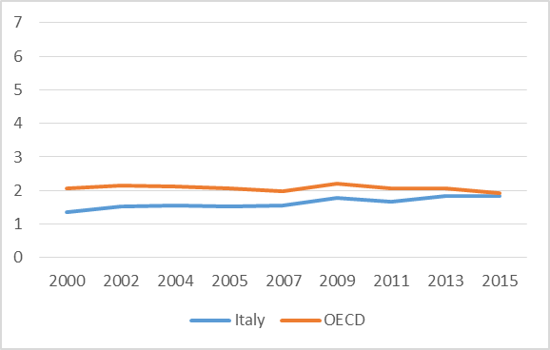 | 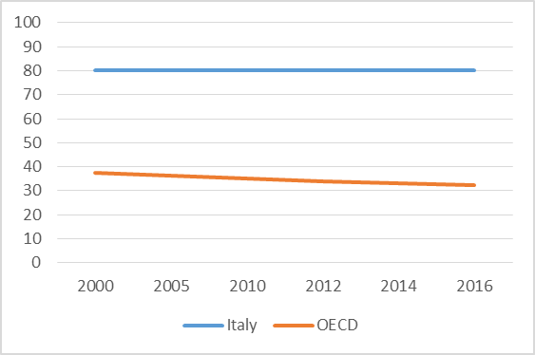 |  |  | 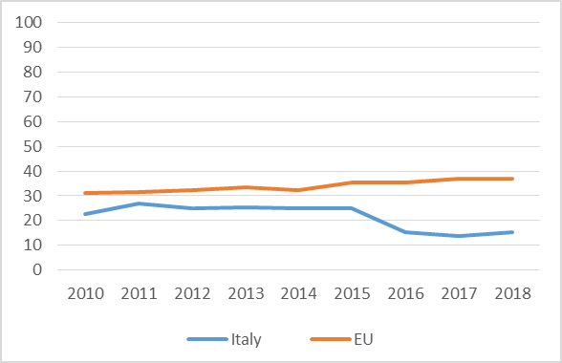
Public spending on incapacity (% of GDP) | Collective bargaining coverage (%) |  |  | Chronic morbidity (% people having long-standing illness or health problems)
Policy framework and key issues for return to work
- The Italian legislation on people with chronic disease (CD) and return to work (RTW) is neither homogeneous (several pieces of legislation apply) nor specifically targeted at people suffering from CD.  - Some provisions on RTW and some other forms of protection derive from the condition of disability, a concept that has moreover taken on different meanings according to the objectives pursued from time to time by the legislator. |  | - Both employers and social partners often lack the legal expertise to deal with CD and RTW.  - RTW policies are not perceived as priorities by social partners and employers often exhibit prejudices about workers with CD, considered to no longer be productive: this leads to attempts to violate and circumvent certain norms.  - Many stakeholders are potentially involved in RTW policies (i.e. employers, social partners, patients’ associations, research organisations, public authorities, public and private job centres) but interactions between them are neither systemic, nor particularly favoured by any coordination effort.
Policy framework |  | Key policy issues
Involvement of social partners in return-to-work policies
- National-level social dialogue has led to some legal provisions on RTW, but social partners complain about lack of sufficient involvement in policymaking.  - Some multipartite social dialogue activities are conducted at the territorial level, especially on active labour policies for people with disabilities.  - The main provisions of National Collective Labour Agreements concern (1) job maintenance, (2) wage protection, (3) work–life balance, and (4) improved access to healthcare.  - Some differences are detected across many sectoral NCLAs as regards the scope and generosity of provisions and their main targets (disabled workers, workers affected by serious and chronic pathologies, workers in need of life-saving therapies, etc.). This makes it difficult for people with diseases to easily understand their entitlements. |  | - RTW for workers with CD does not constitute a prominent topic in company-level collective bargaining.  - Collective provisions in companies mainly concern (1) job and wage protection, (2) work–life balance, (3) healthcare measures, and (4) the establishment of dedicated bilateral committees and professional figures (namely a ‘disability manager’) charged with the launch and coordination of comprehensive projects for the (re-)integration of people with disabilities.  - There are some experiences of collaboration between companies and patients’ associations or employment agencies (also outside the framework of industrial relations) for the inclusion of people with disabilities or CD at work.
National level |  | Company level
Policy recommendations
Recommendations for policymakers  - Make the legislative framework on CD and labour rights more coherent and homogeneous.  - Further shift the focus of legal provisions from mere protection and assistance measures to active policies of adaptation and RTW.  - Promote information and training on legal obligations and opportunities as well as on best practices in this field.  - Foster stronger cooperation between different stakeholders for the implementation of RTW processes. |  | Recommendations for social partners  - Deepen the knowledge of CD at work and improve the ability of local players to bargain over these issues.  - Look for and strengthen multi-stakeholder relationships in this field.  - Engage in cross-sectoral dialogue and pursue greater coherence across different sectoral NCLAs as regards the beneficiaries of RTW policies and the content of social measures.  - Pay greater attention, in both collective agreements and relationships with the rank-and-file, to periods of transition, when workers may feel lost and in need of guidance.
Further information
References

*Sources: Data on public spending on incapacity and collective bargaining coverage are taken from OECD. Chronic morbidity is taken from Eurostat.

The concept is operationalised by a question asking if the respondent suffers from any long-standing (of a duration of at least six months) illness or health problem.

